REPORT ON SCHOOL FEEDING ORIENTATION TO CATERES ON NUTRITION, HYGIENE AND FOOD SAFTEY
We had a meeting with the school feeding caterers to improve the quality of meals served to pupils under Ghana School Feeding Program which was held at the Assembly Hall on the 29th March 2023 at 10:30am.
In attendance were
- The Co-ordinating Director
- The Municipal Environmental Health Officer
- The Agric Department
- The Front Desk Officer
- The Zonal Co-ordinator of School Feeding Program
The Municipal Environmental Health Officer gave a talk on how to keep a clean environment where ever food is being prepared for the pupils and touch on personal hygiene and also separating the raw foods and cooked food in their fridge and freezer to avoid cross contamination and finally talked on medical screening for the cooks before preparing food to the pupils.
After which the participants asked questions and answers were given by the MEHO to solve their problems. We had a fruitful discussion and the meeting came to an end with a closing prayer by a caterer named Miss Bridget.

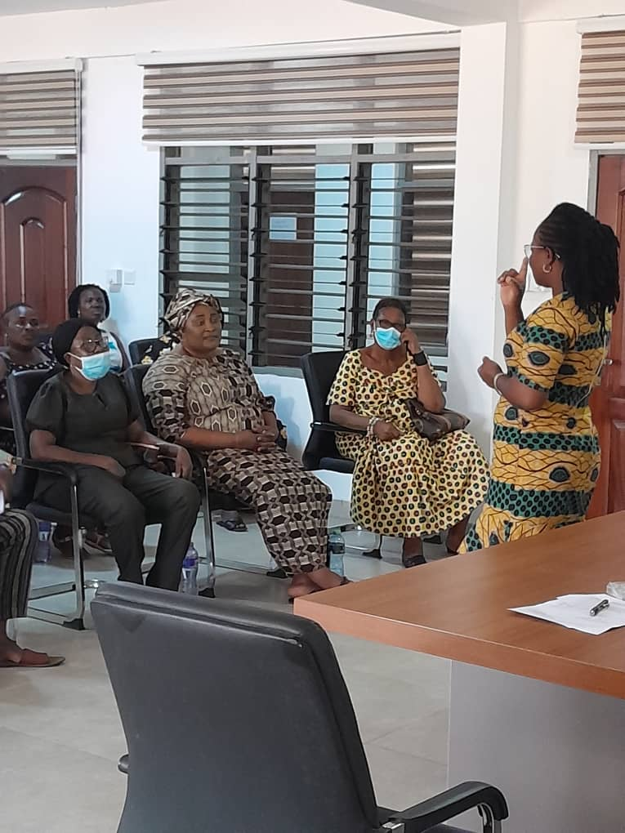
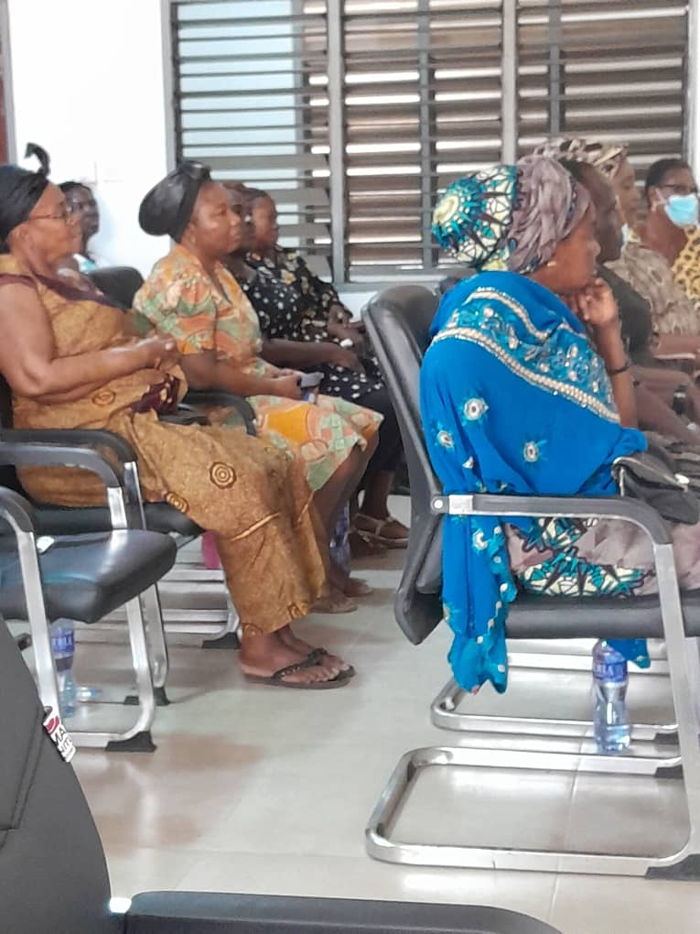

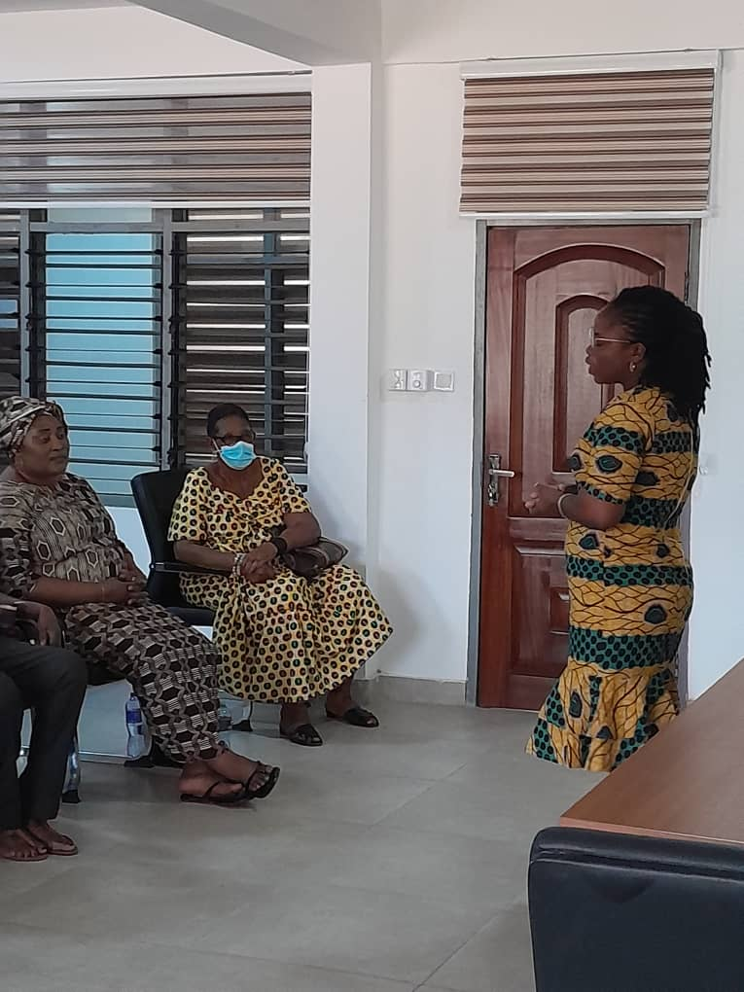

REJOICE WIREDU

